**Form1.cs**

using System;

using System.Collections.Generic;

using System.ComponentModel;

using System.Data;

using System.Drawing;

using System.Text;

using System.Windows.Forms;

using Microsoft.DirectX.Direct3D;

using Microsoft.DirectX;

namespace gppractical5

{

public partial class Form1 : Form

{

Microsoft.DirectX.Direct3D.Device device;

CustomVertex.PositionNormalColored[] vertex = new CustomVertex.PositionNormalColored[3];

public Form1()

{

InitializeComponent();

InitDevice();

}

public void InitDevice()

{

PresentParameters pp = new PresentParameters();

pp.Windowed = true;

pp.SwapEffect = SwapEffect.Discard;

device = new Device(0, DeviceType.Hardware, this, CreateFlags.HardwareVertexProcessing, pp);

}

private void Form1_Paint(object sender, PaintEventArgs e)

{

device.Clear(ClearFlags.Target, Color.LightBlue, 1, 0); device.Present();

device.BeginScene();

device.VertexFormat = CustomVertex.PositionNormalColored.Format;

device.DrawUserPrimitives(PrimitiveType.TriangleList, vertex.Length / 3, vertex);

device.EndScene();

device.Present();

}

private void Form1_Load(object sender, System.EventArgs e)

{

PresentParameters pp = new PresentParameters();

pp.Windowed = true;

pp.SwapEffect = SwapEffect.Discard;

device = new Device(0, DeviceType.Hardware, this, CreateFlags.HardwareVertexProcessing, pp);

device.Transform.Projection = Matrix.PerspectiveFovLH(3.14f / 4, device.Viewport.Width / device.Viewport.Height, 1f, 1000f);

device.Transform.View = Matrix.LookAtLH(new Vector3(0, 0, 10), new Vector3(), new Vector3(0, 1, 0));

device.RenderState.Lighting = false;

vertex[0] = new CustomVertex.PositionNormalColored(new Vector3(0, 1, 1), new Vector3(1, 0, 1), Color.White.ToArgb());

vertex[1] = new CustomVertex.PositionNormalColored(new Vector3(-1, -1, 1), new Vector3(2, 0, 1), Color.White.ToArgb());

vertex[2] = new CustomVertex.PositionNormalColored(new Vector3(1, -1, 1), new Vector3(2, 0, 1), Color.White.ToArgb());

device.RenderState.Lighting = true;

device.Lights[0].Type = LightType.Directional;

device.Lights[0].Diffuse = Color.Blue;

device.Lights[0].Direction = new Vector3(-1f, 0, -2);

device.Lights[0].Enabled = true;

}

}

}

**OUTPUT**

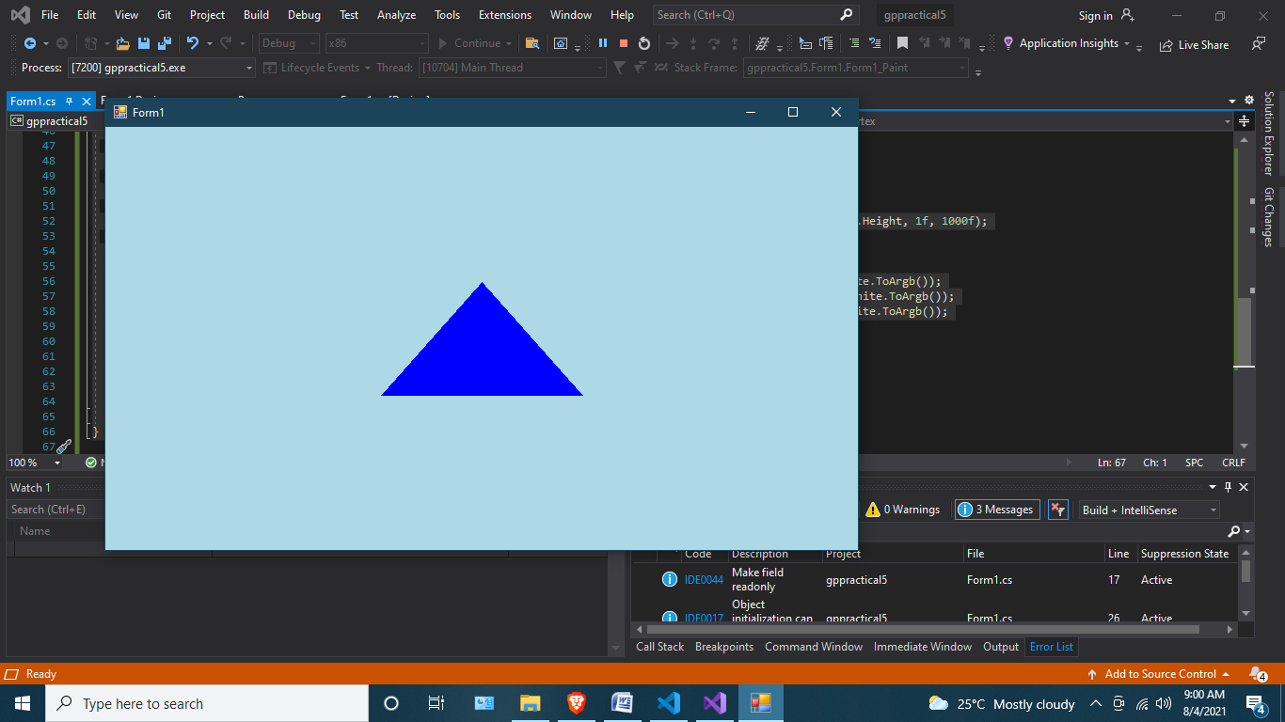

**Form2.cs**

using System;

using System.Collections.Generic;

using System.ComponentModel;

using System.Data;

using System.Drawing;

using System.Text;

using System.Windows.Forms;

using Microsoft.DirectX;

using Microsoft.DirectX.Direct3D;

namespace gppractical5

{

public partial class Form1 : Form

{

Microsoft.DirectX.Direct3D.Device device;

private CustomVertex.PositionNormalColored[] vertex = new CustomVertex.PositionNormalColored[6];

public Form1()

{

InitializeComponent();

}

private void Form1_Paint(object sender, PaintEventArgs e)

{

device.Clear(ClearFlags.Target, Color.Violet, 1.0f, 0);

device.BeginScene();

device.VertexFormat = CustomVertex.PositionNormalColored.Format;

device.DrawUserPrimitives(PrimitiveType.TriangleList, vertex.Length / 3, vertex);

device.EndScene();

device.Present();

}

private void Form1_Load(object sender, EventArgs e)

{

PresentParameters pp = new PresentParameters();

pp.Windowed = true;

pp.SwapEffect = SwapEffect.Discard;

device = new Device(0, DeviceType.Hardware, this, CreateFlags.HardwareVertexProcessing, pp);

device.Transform.Projection = Matrix.PerspectiveFovLH(3.14f / 4, device.Viewport.Width / device.Viewport.Height, 1f, 1000f);

device.Transform.View = Matrix.LookAtLH(new Vector3(0, 0, 10), new Vector3(), new Vector3(0, 1, 0));

device.RenderState.Lighting = true;

vertex[0] = new CustomVertex.PositionNormalColored(new Vector3(0, 0, 4), new Vector3(-1, 0, -1), Color.Pink.ToArgb());

vertex[1] = new CustomVertex.PositionNormalColored(new Vector3(2, 0, 4), new Vector3(1, 0, 1), Color.Pink.ToArgb());

vertex[2] = new CustomVertex.PositionNormalColored(new Vector3(2, 2, 4), new Vector3(-1, 0, -1), Color.Pink.ToArgb());

vertex[3] = new CustomVertex.PositionNormalColored(new Vector3(0, 2, 4), new Vector3(1, 0, 1), Color.Pink.ToArgb());

vertex[4] = new CustomVertex.PositionNormalColored(new Vector3(0, 0, 4), new Vector3(-1, 0, -1), Color.Pink.ToArgb());

vertex[5] = new CustomVertex.PositionNormalColored(new Vector3(2, 2, 4), new Vector3(-1, 0, -1), Color.Pink.ToArgb());

device.Lights[0].Type = LightType.Directional;

device.Lights[0].Diffuse = Color.Red;

device.Lights[0].Direction = new Vector3(-1f, 1, -1);

device.Lights[0].Enabled = true;

} }

}

